Effects of Covid-19 Pandemic in Essex, MA

* Runting Shao -

1. Introduction

The coronavirus outbreak that began in February 2020 strikes a serious blow at the U.S. labor market and causes millions of Americans to leave the workforce. As it has a significant effect on the US economy, the unemployment during the pandemic has affected every American’s life. Without stable income, many Americans can barely survive without enough food supplies and lack of rent.

Besides the effects of the pandemic on employment, I also investigate how covid confirmed cases are affected by the mask mandates policy in Essex, MA.

1. Background/Related Work

According to the article “Tracking the COVID-19 Economy’s Effects on Food, Housing, and Employment Hardships”, the hardship rates increase especially fast as people keep losing jobs during the pandemic. Without stable income, people are having trouble getting enough food, paying house rent or mortgage and having difficulty covering household expenses. However, this article only shows how people in the US are impacted with unemployment during the pandemic. We still have no idea on the unemployment situation in local areas. Therefore, for this project, I choose Essex county in MA to investigate the impact of covid on unemployment in the local area.

This project aims to look into the insights on the following questions:

* How does the mask mandates policy affect the covid confirmed cases in Essex, MA?
* How is unemployment of residents in Essex, MA affected by Covid19?
* How is the unemployment rate in Essex, MA compared with the unemployment rate in the whole state from 2020 to 2021?
* Is unemployment and loss of labor force correlated with covid confirmed cases or death cases?

1. Methodology

Data Preparation: I extract both unemployment data and covid data in Essex,MA from the original datasets and merge these two together by dates.

Visualization: I will create time series visualizations with both unemployment data and covid confirmed cases to examine the trends of unemployment during pandemic. I will also compare the unemployment rate in Essex county with the unemployment rate in MA.

Correlation Analysis: I will apply a pairplot to qualify the possible correlation between covid data and unemployment data.

Analyzing the time series visualizations can help to understand how the unemployment status has changed with time. In this way, we can see what the unemployment statistics looked like before and after the outbreak of Covid19.

1. Findings

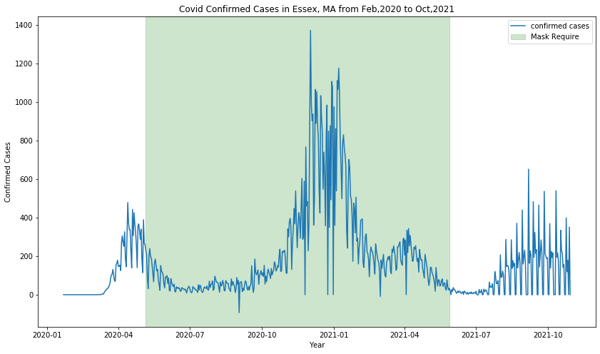

This graph shows the covid daily confirmed cases in Essex, MA from Feb 2020 to October, 2021 under the reflection of mask mandate policy in Essex, MA. The viewer can tell that it is a time-series plot with date as the x-axis. The period of mask requirement is highlighted as a green area in the plot. I can’t see any effect the mask mandates policy has on controlling the new confirmed cases of covid-19 from this graph.

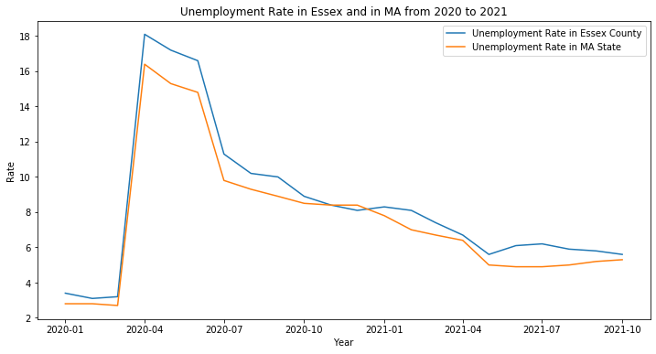

This graph shows the unemployment rate in Essex county and the unemployment rate in the whole state of Massachusetts. As we can see, at most of the time, Essex county has a higher unemployment rate than the unemployment rate in its state.

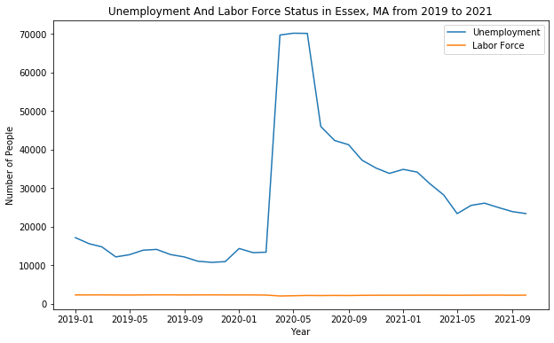

From this graph, we can see that after the outbreak of covid19, there is a sudden rise in unemployment numbers and the total labor force has decreased a little bit.

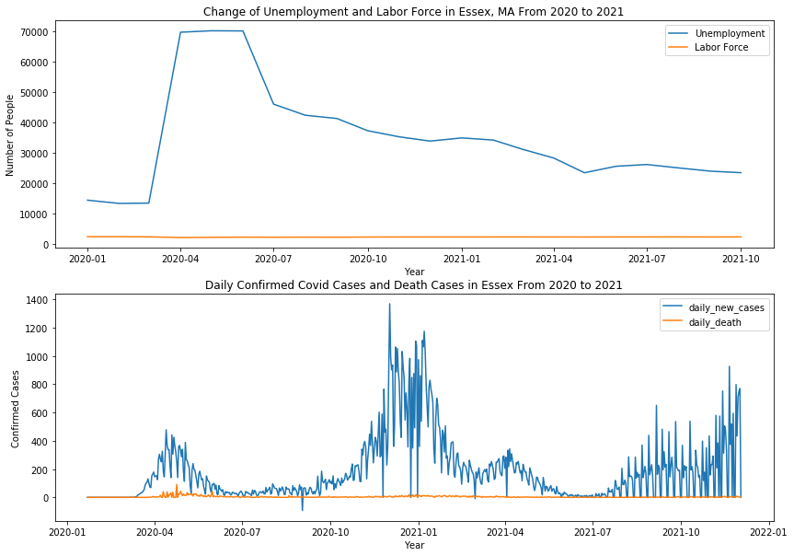

From this graph, we can see that during the first peak wave of covid-19, as the rise of daily confirmed cases and death cases, there is an obvious rise of unemployment and a little loss of labor force. However, after the first wave, the number of unemployment has gradually decreased even during the peak of the daily confirmed cases.

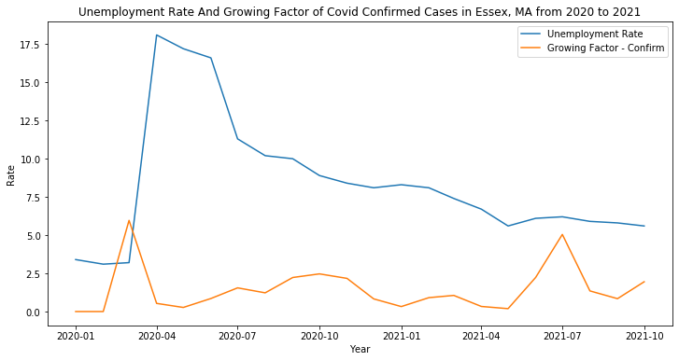

I also calculated the growing factor of daily confirmed cases and death cases to compare with the unemployment rate. Another thing I noticed is that the time of the sudden rise of unemployment is during March and April, which is a little behind the time of the first peak of covid cases in January and February.

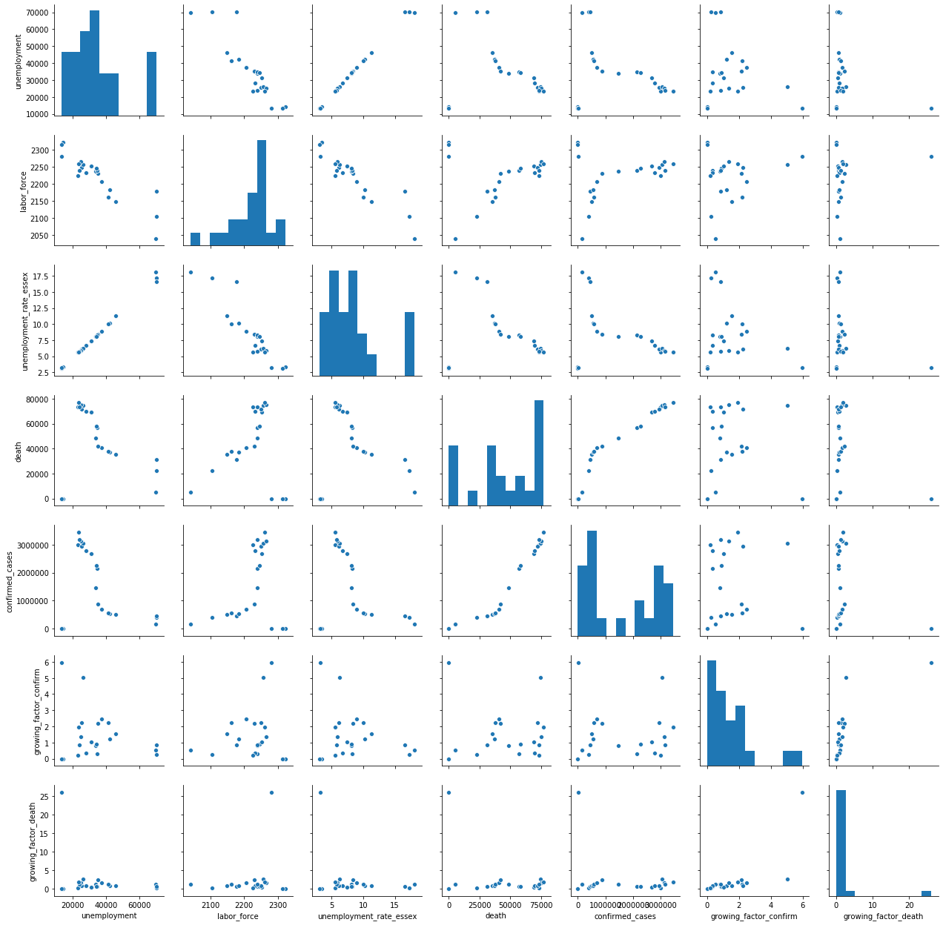

According to the pair plot, covid death cases are not correlated with the loss of labor force. The covid confirmed cases are not correlated with unemployment. The growing factor of covid confirmed cases is not correlated with the unemployment rate.

1. Discussion/Implications

Disasters like covid19 that affect the lives of people all over the world can never be truly avoided. However, understanding the relationship between covid19 and unemployment and the timing of the unemployment rate can guide decision-making when the next disaster strikes and thus avoid greater losses.

1. Limitations

I planned to investigate the job losses of people with different wages, different occupations, different races and different gender to see which specified group has been mostly affected by Covid-19. However, I could not find the specified data for Essex County, MA. These aspects with local employment could be analyzed in the future if more specific datasets are available.

1. Conclusion

The initial outbreak of Covid-19 is related with the sudden rise of unemployment and loss of labor force in Essex, MA. However, the unemployment situation has not deteriorated further as the daily confirmed cases reach their peak. On the contrary, the statistics of unemployment and loss of labor force in Essex, MA have gradually returned to the previous state before the outbreak of Covid-19.

1. References

*Tracking the COVID-19 economy's effects on food, housing, and employment hardships*. Center on Budget and Policy Priorities. (n.d.). Retrieved December 14, 2021, from https://www.cbpp.org/research/poverty-and-inequality/tracking-the-covid-19-economys-effects-on-food-housing-and.

1. Data Sources

COVID-19 Data Repository by the Center for Systems Science and Engineering (CSSE) at Johns Hopkins University:

<https://github.com/CSSEGISandData/COVID-19>

The CDC dataset of [masking mandates by county](https://data.cdc.gov/Policy-Surveillance/U-S-State-and-Territorial-Public-Mask-Mandates-Fro/62d6-pm5i).

The New York Times [mask compliance survey](https://github.com/nytimes/covid-19-data/tree/master/mask-use) data.

Local Area Unemployment Statistics from the Bureau of Labor Statistics:

<https://beta.bls.gov/dataQuery/find?q=county&q=essex,+MA%20county>